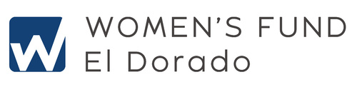

Wickline Scholarship History

The Wickline Scholarship was established to assist women residing on the western slope of El Dorado County trying to overcome personal hardships by pursuing a post-secondary education. Local colleges and nonprofits are contacted each year to encourage eligible women to apply. The funding of each year’s scholarship comes from proceeds earned by the Wickline Scholar Endowment Fund in the prior year.

The creation of this award began in 2009 when Marian Wickline left a legacy gift to the El Dorado Community Foundation (EDCF). When the Foundation learned more about Ms. Wickline’s accomplishments (graduating from Mills College in 1934; one of very few women to earn a degree in chemistry at that time; and having a successful career as a chemist) they decided a perfect way to honor Ms. Wickline’s gift would be through the Women’s Fund El Dorado (WFED).

WFED was offered a grant of $10,000 from the Wickline legacy gift. With the grant came a challenge: if an additional $10,000 was raised to match the $10,000 gift by April 15, 2012, then WFED would receive that legacy as well as an additional $30,000 from EDCF to create the Wickline Scholar Endowment Fund. WFED succeeded in reaching its goal in February 2012. The $50,000 of combined gifts in the Wickline Scholar Endowment Fund enables WFED to offer the award on an annual basis for generations to come. No part of WFED’s membership donations go to the Wickline Fund.

In her career, Marian supervised the Chemical Information Department at Dow Chemical in Walnut Creek. She lived in Danville, CA where she was an active member in the community for 27 years before moving to Placerville in 1988. In Placerville, Marian became involved with local affairs and served on several county commissions. She was a member of the American Association of University Women, American Chemical Society and Special Libraries Association.

According to friend, Mary Jane Battaglia, Marian was always interested in starting discussion groups in the Placerville branch of AAUW. “We had monthly meetings. It was like a local “The View.” We were delighted to have the opportunity to exchange ideas about local politics, national politics and international politics – and anything else in between.”

WFED is humbled and grateful to Marian Wickline and EDCF for the opportunity to help women on the western slope improve their lives.

